IT24103914

Abeywickrama N. H.

IT2120 - Probability and Statistics Lab Sheet 07

Exercise

01)

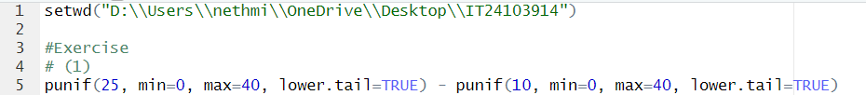

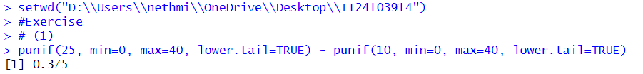

02)



03)

Part 1

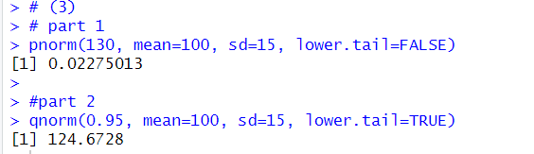

Part 2

